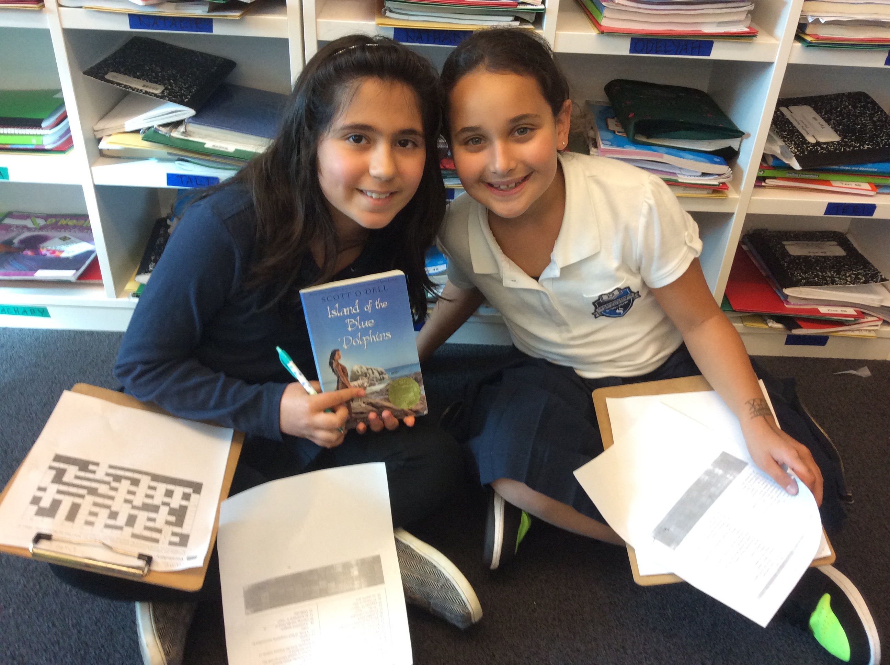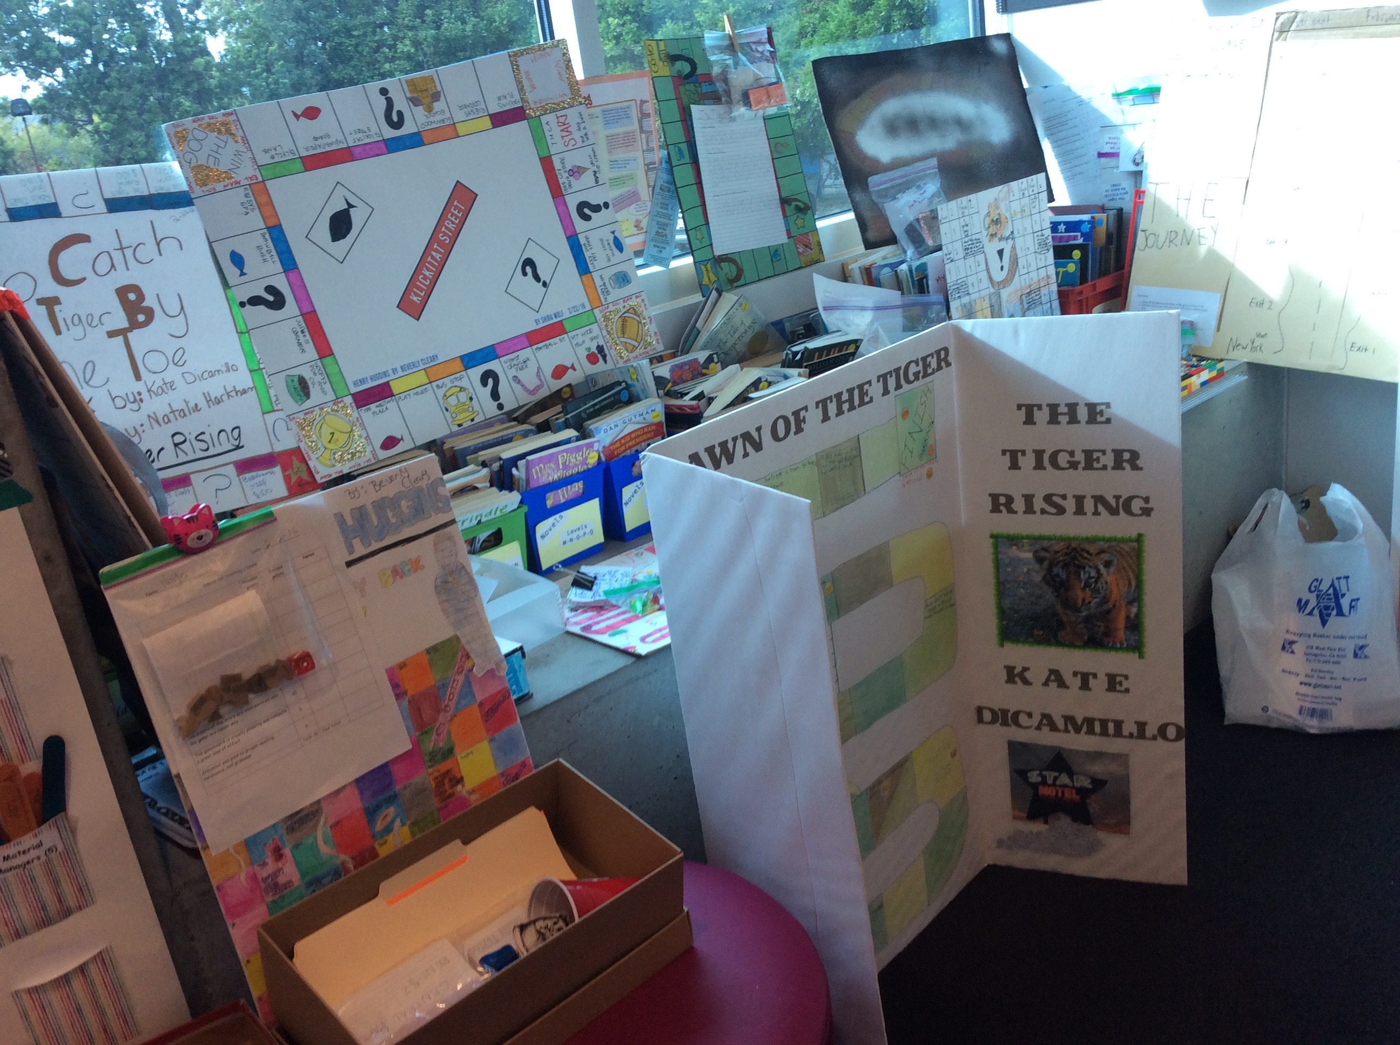

**MATH:**

- Chapter 8- *Adding and Subtracting Decimals*

**READING:**

-Island of the Blue Dolphins

-CARS benchmark #4

**LANGUAGE ARTS:**

-Grammar- more of unit 3, dictation prep (homophones)

-Wordly Wise- Lesson 10

**SOCIAL STUDIES:**

-California Missions

MARCH 4, 2016

NEW WEBSITE UPDATE!

Check out our math page where we posted a link to “[Thinking Blocks](http://www.mathplayground.com/tb_multiplication/thinking_blocks_multiplication_division.html),” a fun and interactive way to practice using bar models to solve word problems on the computer! (We will revisit using bar models in lesson 8.3- this site provides some basic but helpful practice!)

**MATH**

This week we reviewed the chapter 7 test and began Chapter 8: Adding and Subtracting Decimals. We were pleased with the chapter 7 test results and were glad to see that students have a solid foundation for understanding decimals in the tenths and hundredth places. Chapter 8 has students adding and subtracting decimals with and without regrouping. When helping or working with your child, note to look out for how they copy and write problems vertically. We emphasized thinking about where the numbers go with regards to the decimal point. For example, when solving 5 - .7 vertically, the .7 would NOT go directly under the 5, as the 5 is a whole number, and the 7 in “.7” is in the tenths place. Using a placeholder zero and writing 5 as “5.0” is helpful in this case.

We are excited to give students the opportunity for more problem solving in lesson 8.3. We will cycle back to the use of bar models and variables to solve multi-step word problems involving decimals. Please refer to the extra practice pages and to the latest update to our website on our math page, “[thinking blocks](http://www.mathplayground.com/tb_multiplication/thinking_blocks_multiplication_division.html).” Our chapter 8 test will be one week from today on Friday, March 11th.

Ms. Giss and Mrs. Daftari’s Motivated

4th Grade

**UPCOMING TESTS/IMPORTANT DATES:**

-PUPIL FREE DAY: MONDAY MARCH 7TH: PTC

- 1:40 DISMISSAL TUESDAY MARCH 8TH: PTC

NO spelling next week (short week and continue with grammar)

- Thursday March 10th- Wordly Wise test #10

-Friday March 11th- Math test chapter 8

**SOCIAL STUDIES: THE STUDY OF THE CALIFORNIA MISSIONS**

This week we continued the “story” we began to tell when we worked on the Galleon Game. We gave students an overview of what happened to the Native Americans who were living in California when the Spanish explorers arrived. We reminded them that one of the reasons that the Spanish came was to spread their religion of Christianity. We talked about the culture clash between the natives and the Spanish and introduced the advent of the California missions, started by Father Junipero Serra in the hopes of spreading Christianity. Students are interested in this story and in the study of the California missions. Next week, they will read in greater detail about this time period. They will get to know the parts and workings of a mission and they will get to know one mission they will be assigned to, in greater detail. We look forward to completing an in-class research project on the California missions and we will continue to keep you posted!

**READING**

We were blown away by the effort, creativity, thoughtfulness, artwork, and craftsmanship of the final projects for our guided reading novels! Thank you for your own efforts, support, and involvement when it was necessary. Students were proud to share their hard work and were impressed by the work of their peers. Games will be played, chapters will be shared, and digital book talks will be watched. What a brilliant culmination to an in depth novel study! The way in which students applied their understanding of their novels to their work was impressive. We look forward to posting photos on our website soon!

Students continue to be captivated by our whole class novel, Scott O Dell’s Island of the Blue Dolphins. This week we read about the battle between the Russian Aleuts who came to the island and the Ghalas-at natives. Students are appreciating the suspense and the descriptive nature of Scott O Dell’s writing. They are fiercely taking notes while we read, documenting the thinking they are doing. It is wonderful to see the natural way in which they ask questions, make inferences, and judge the characters, while bringing evidence from the text. They are beginning to make connections to social studies and California history as they realize the historical pieces of the novel.